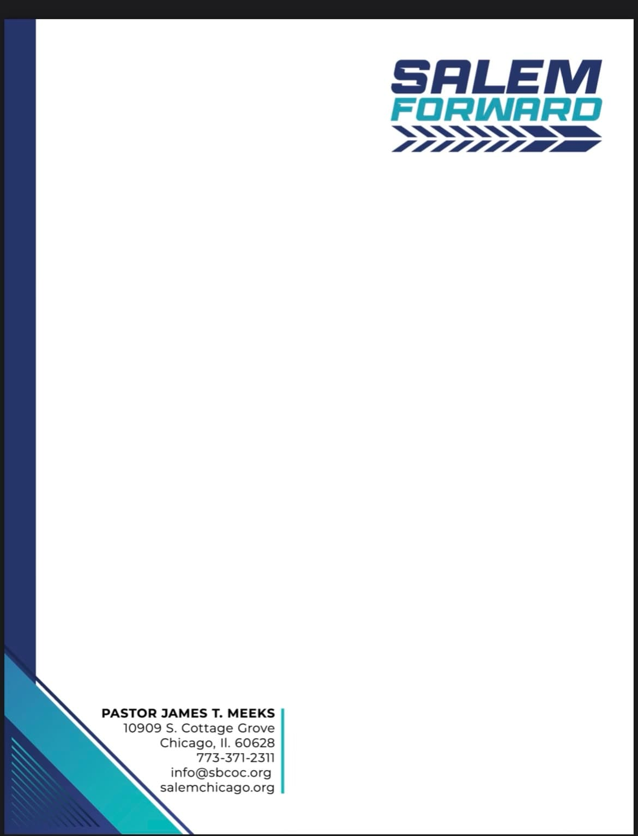
Sender Name
Sender Organization’s Name
Street
City State Zip

Dear [Employer],

I hope this message finds you well. As an employee of [Company Name], I am proud to work for a company that values community engagement and giving back to those in need. I wanted to bring to your attention an important cause that I am personally involved in and that I believe our company would benefit from supporting.

Salem Baptist Church of Chicago has launched an initiative called Salem Forward, which aims to change the future! How do you change the future you ask? By investing in HOPE. Salem is creating programs that improve the educational and economic outcomes of a historically divested community. One of the key programs under this initiative is the Black Boy Literacy Program. The goal of this program is to dramatically improve the reading scores of 1,000 African American boys between first and third grade by the end of this year through a full day intensive summer camp and weekend programming through the fall.

As you can imagine, this is a massive undertaking that requires the support of the entire community. That's why I am reaching out to you today. We are looking to reach our Salem Forward fundraising goal by April 9th, 2023, and any donation from [Company Name] would help us get there.

I am proud to work for a company that has the power to make a positive impact in the lives of children around us. Would you consider supporting this initiative and help build a community we can all be proud to be part of?

To learn more about all we have planned under this initiative, please see this special message from Dr. Dates. Your tax deductible gift can be made using this link. If you have any questions or if there is anything I can do to help facilitate a donation from [Company Name], please let me know. Or, if you’d like to speak with someone from Salem, you can contact Denise Rogers, Salem’s COO at drogers@sbcoc.org.

Thank you for your time and consideration.

Sincerely,

[Sender Name]

Rev. Dr. Charlie Dates, Senior Pastor
Pastor James T Meeks, Pastor Emeritus

Salem Baptist Church of Chicago
10909 S. Cottage Grove
Chicago, IL, 60628
SalemChicago.org

